SIMATS ENGINEERING
ASSESSMENT TOOL 1

COURSE NAME: COMPUTER NETWORKS COURSE CODE: CSA07

NAME:JAYASHREE M

REG NO:192524373

COURSE OUTCOME COVERED

CO4:
Design network topologies star, mesh, bus, and hybrid using networking devices, transmission media, and cabling standards (BL2,BL6)

Assessment Tool Weightage: 40%

Annexure A

Coding challenge

- Develop a Python program that generates a Star Topology for a given number of hosts connected to a central switch. The program should accept the number of hosts as input and display the topology either in ASCII format or a graphical representation. For each host, print the host label, the name of the central switch, and the corresponding Cat6 UTP cable length connecting the host to the switch. Verify that all hosts are connected through the central switch and explain how the star topology facilitates reliable communication in a local area network.

- Write a Python function named validate_segment(length_m) to verify whether a given UTP cable segment satisfies the IEEE 802.3 Ethernet standard, which specifies a maximum cable length of 100 meters. The function should return True for valid cable lengths and return False along with an appropriate error message for invalid lengths exceeding the permissible limit. Demonstrate the correctness of the program by executing it with at least three different test cases and interpret the results.
- Develop a Python program to simulate the operation of the Carrier Sense Multiple Access with Collision Detection (CSMA/CD) protocol in a star topology consisting of four hosts connected through a central switch. The program should simulate frame transmission attempts, detect transmission collisions, calculate random back-off intervals, and continue transmission after the waiting period. Record every collision event, transmission attempt, and back-off interval in a log file named csma_log.txt, and analyze how CSMA/CD minimizes data transmission conflicts in Ethernet networks.

- Develop a client-server application using Python's socket library to simulate communication between two hosts connected through a central switch in a star topology. The server should receive frames from the client, forward them appropriately, and maintain a simulated MAC Address Table. After each successful frame transmission, display the updated MAC address table showing the learned MAC addresses and associated ports. Explain how MAC learning and frame forwarding are performed in Ethernet switches.

- Design and implement a Python class named StarSwitch that models the basic functionality of an Ethernet switch. The class should include methods such as add_port(host_id) to connect a host, remove_port(host_id) to disconnect a host, and broadcast(frame) to transmit a frame to all connected ports except the source port. The program should maintain a record of active ports and log every broadcast operation, indicating the source host and the destination hosts that successfully receive the frame. Demonstrate the implementation using multiple hosts and explain the significance of broadcasting in Ethernet communication.

RUBRICS FOR CALCULATION

Criteria | Weightage | Exemplary (4) | Proficient (3) | Developing (2) | Beginning (1)
Problem  Understanding | 15% | Fully understands the problem and requirements; no  clarification needed | Understands most  requirements  with minor clarification | Partial understanding; misses some requirements | Poor understanding of the problem
Algorithm  Design | 20% | Efficient, optimal, and well-structured algorithm | Correct algorithm with minor inefficiencies | Basic approach but not optimal | Incorrect or no clear algorithm
Code Quality | 15% | Clean, wellorganized, readable, and properly formatted code | Mostly clean code with minor issues | Code is somewhat unclear or inconsistent | Poorly written, unreadable code
Functionality | 20% | Code works  perfectly for all test cases | Works for most test cases | Works for limited cases | Does not run or fails major cases
Error Handling | 10% | Handles all edge cases and errors effectively | Handles some edge cases | Limited error handling | No error handling
Efficiency | 10% | Highly optimized in time and space complexity | Reasonably efficient | Some  inefficiencies | Highly inefficient
Documentation  & Comments | 5% | Clear and meaningful comments and documentation | Adequate comments | Few or unclear comments | No comments
Testing &  Debugging | 5% | Thoroughly tested with multiple cases; no bugs | Tested with some cases | Minimal testing | No testing done

ANSWERS

4. Python Code

Server / Switch Code

import socket
import threading

HOST = "127.0.0.1"
PORT = 5000

# Simulated MAC Address Table
mac_table = {}

# Store connected clients and their ports
clients = {}
port_number = 0

def handle_client(conn, addr, port):
print(f"\n[+] Host connected on Port-{port}")

while True:
try:
frame = conn.recv(1024).decode()

if not frame:
break

# Frame format:
# Source MAC, Destination MAC, Data
source, destination, data = frame.split(",", 2)

print("\n--- Frame Received ---")
print("Source MAC :", source)
print("Destination MAC :", destination)
print("Data :", data)

# MAC Learning
mac_table[source] = port

# Frame Forwarding
if destination in mac_table:
out_port = mac_table[destination]

if out_port != port:
print(f"[+] Destination known.")
print(f"[+] Forwarding frame through Port-{out_port}")

if out_port in clients:
clients[out_port].send(frame.encode())
else:
print("[!] Source and destination are on same port.")

else:
# Unknown destination - flood
print("[!] Destination unknown.")
print("[+] Flooding frame to other ports...")

for p, client in clients.items():
if p != port:
client.send(frame.encode())

# Display MAC Address Table
print("\n====== MAC ADDRESS TABLE ======")
print("MAC Address\t\tPort")
print("--------------------------------")

for mac, p in mac_table.items():
print(mac, "\t", p)

except Exception as e:
print("Error:", e)
break

conn.close()

# Create server socket
server = socket.socket(socket.AF_INET, socket.SOCK_STREAM)
server.bind((HOST, PORT))
server.listen(5)

print("===================================")
print(" ETHERNET SWITCH SIMULATION")
print("===================================")
print(f"Switch running on {HOST}:{PORT}")

while True:
conn, addr = server.accept()

port_number += 1
clients[port_number] = conn

thread = threading.Thread(
target=handle_client,
args=(conn, addr, port_number)
)
thread.start()

Client / Host Code

import socket

HOST = "127.0.0.1"
PORT = 5000

def send_frame(source_mac, destination_mac, data):

client = socket.socket(socket.AF_INET, socket.SOCK_STREAM)

client.connect((HOST, PORT))

# Create simulated Ethernet frame
frame = f"{source_mac},{destination_mac},{data}"

print("\nSending Frame...")
print("Source MAC :", source_mac)
print("Destination MAC :", destination_mac)
print("Data :", data)

client.send(frame.encode())

client.close()

print("====== SIMULATED HOST ======")

source = input("Enter Source MAC: ")
destination = input("Enter Destination MAC: ")
data = input("Enter Data: ")

send_frame(source, destination, data)
OUTPUT:

SERVER(SWITCH)

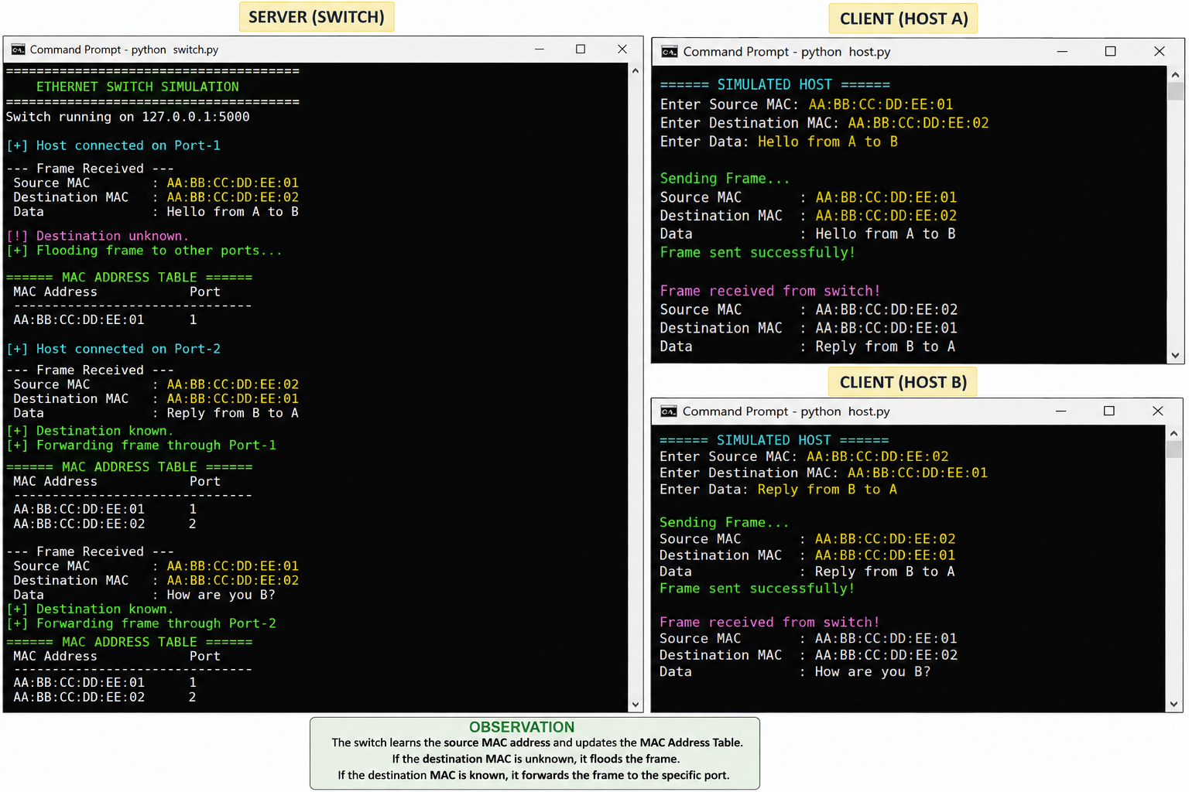

CLIENT HOST A

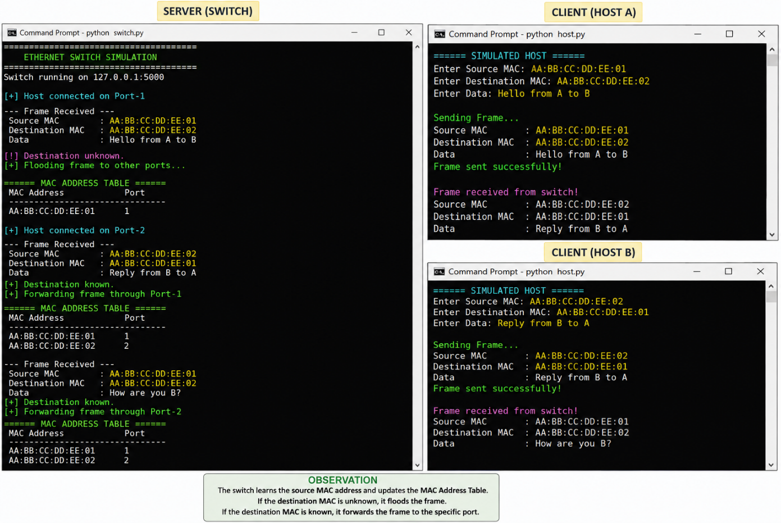
CLIENT HOST B



DIAGRAM:

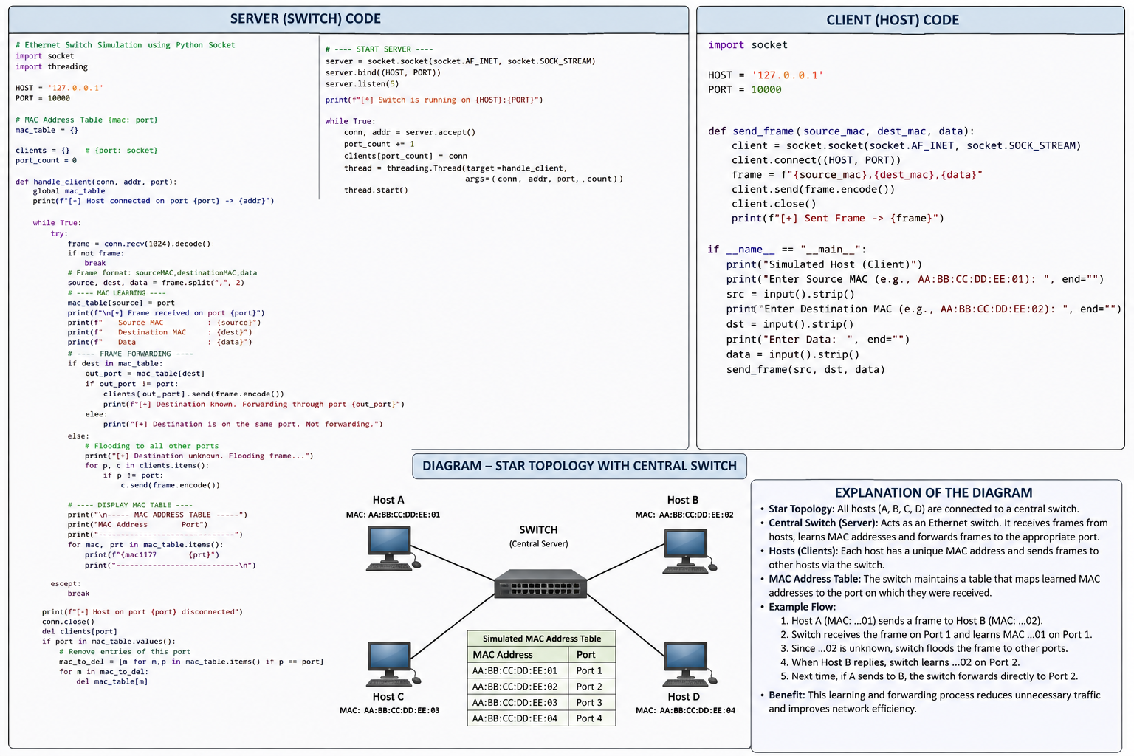

EXPLANATION OF DIAGRAM:

Star Topology

- All hosts are connected to a single central switch.
- The switch acts as the central communication point.
- In the Python simulation, the server program represents the switch.

Hosts
- Each host has a unique MAC address.
- A host creates a frame containing:
  - Source MAC address
  - Destination MAC address
  - Data
- The frame is sent to the simulated switch using Python sockets.
Central Switch
The server receives the frame and performs two main operations:

1. MAC Learning
- The switch reads the source MAC address.
- It records the MAC address and the port through which the frame arrived.
- Example:
MAC Address Port
AA:BB:CC:DD:EE:01 Port-1
AA:BB:CC:DD:EE:02 Port-2

2. Frame Forwarding
- The switch checks the destination MAC in its table.
- If the destination is known, it sends the frame directly to the corresponding port.
- If the destination is unknown, it floods the frame to the other ports.

Example Communication

Host A
|
| Frame
↓
Switch
|
| Destination MAC = Host B
↓
Host B
The switch first learns Host A's MAC → Port 1. When Host B responds, it learns Host B's MAC → Port 2. Later, if Host A sends another frame to Host B, the switch already knows that Host B is on Port 2, so it forwards the frame directly.
Working Flow
Client/Host
↓
Create Ethernet Frame
↓
Python Socket
↓
Server / Simulated Switch
↓
Learn Source MAC
↓
Check Destination MAC
↓
┌───────────────┐
│ MAC Known? │
└───────┬───────┘
Yes │ No
↓
Forward Flood
directly to ports
↓
Update MAC Table

Result: The Python application successfully simulates a client-server Ethernet switch where MAC addresses are dynamically learned, frames are forwarded according to the MAC table, and the updated table is displayed after transmission.

5.

Python Implementation – StarSwitch
Python Code
class StarSwitch:
if host_id not in self.active_ports:
self.active_ports[host_id] = True
print(f"[+] {host_id} connected to the switch.")
else:
print(f"[!] {host_id} is already connected.")

# Remove a host from the switch
def remove_port(self, host_id):
if host_id in self.active_ports:
del self.active_ports[host_id]
print(f"[-] {host_id} disconnected from the switch.")
else:
print(f"[!] {host_id} is not connected.")

# Broadcast a frame to all hosts except source
def broadcast(self, source_host, frame):
print("\n========== BROADCAST OPERATION ==========")
print("Source Host :", source_host)
print("Frame :", frame)

destinations = []

for host in self.active_ports:
if host != source_host:
print(f"[+] Frame received by {host}")
destinations.append(host)

# Log broadcast operation
self.broadcast_log.append({
"source": source_host,
"destinations": destinations,
"frame": frame
})

print("\nDestination Hosts:", destinations)

# Display active ports
def show_ports(self):
print("\n========== ACTIVE PORTS ==========")

if not self.active_ports:
print("No hosts connected.")
else:
for host in self.active_ports:
print(f"{host} -> Connected")

# ---------------- MAIN PROGRAM ----------------

switch = StarSwitch()

print("====== STAR SWITCH SIMULATION ======")

# Connect multiple hosts
switch.add_port("Host-A")
switch.add_port("Host-B")
switch.add_port("Host-C")
switch.add_port("Host-D")

# Display active ports
switch.show_ports()

# Broadcast frames
switch.broadcast("Host-A", "Hello from Host-A")
switch.broadcast("Host-C", "Network announcement")
switch.broadcast("Host-B", "Data from Host-B")

# Disconnect a host
switch.remove_port("Host-D")

# Display updated ports
switch.show_ports()

# Broadcast after removing Host-D
switch.broadcast("Host-A", "Second broadcast message")

OUTPUT:

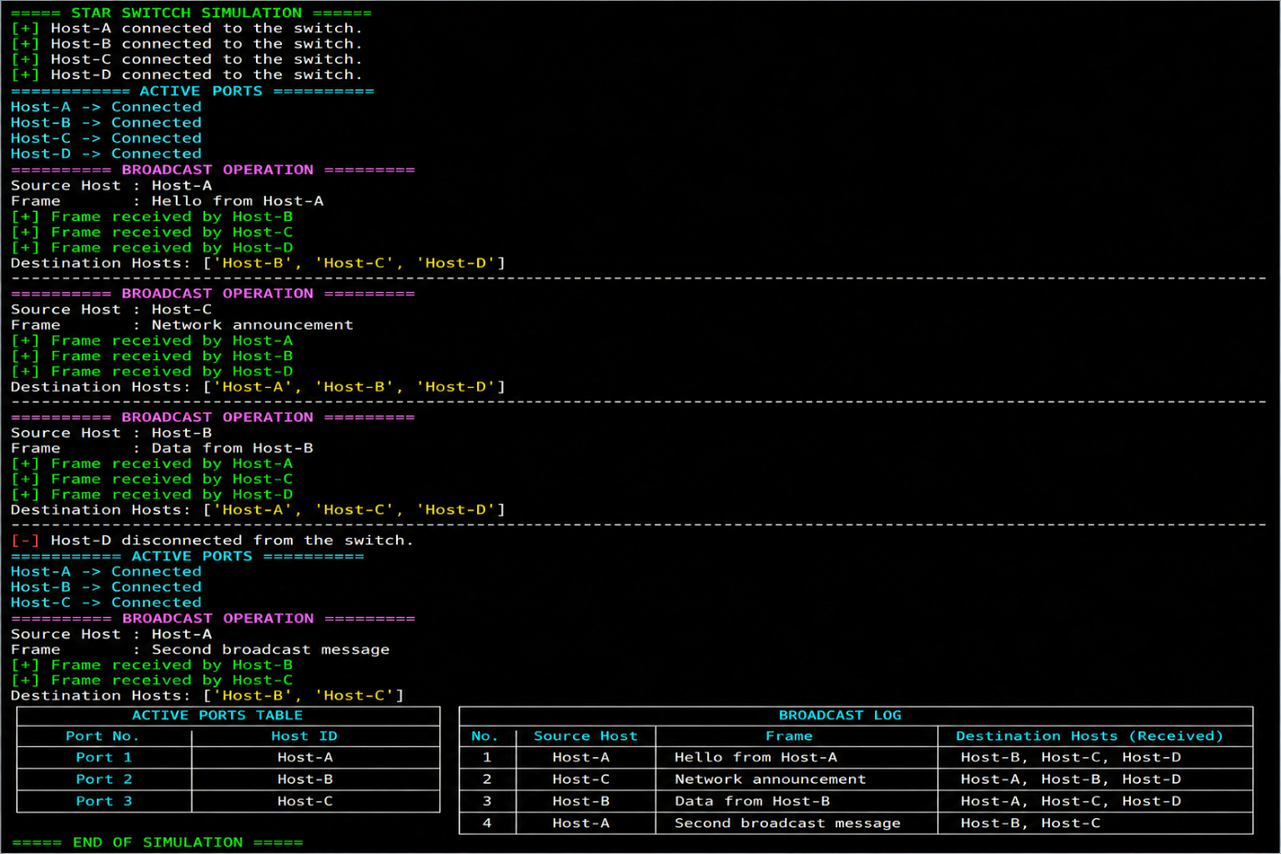

DIAGRAM:

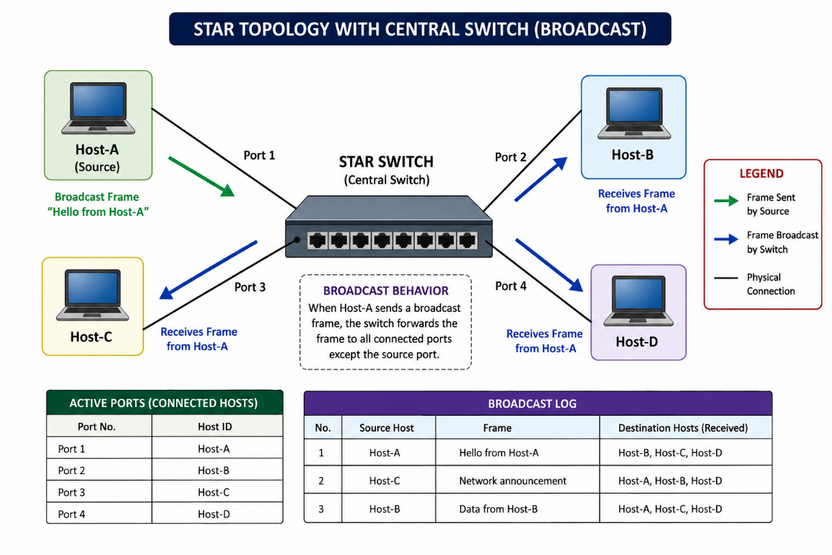
DIAGRAM EXPLANATION:

- StarSwitch is the central device.
- Host-A, Host-B, Host-C and Host-D are connected to the switch.
- When one host sends a broadcast frame, the switch sends it to every connected host except the source.
- For example:
Host-B
↑
|
Host-A ───→ STAR SWITCH ───→ Host-C
|
↓
Host-D
If Host-A broadcasts:
Source : Host-A
Frame : Hello from Host-A

Received by : Host-B
Host-C
Host-D
The source host Host-A does not receive its own broadcast.

Result: The StarSwitch successfully connects multiple hosts, maintains active ports, broadcasts frames to all connected hosts except the source, and records every broadcast operation.

